Data Quality Report: Library Data Warehouse
Database: library_dw
Author: Group03
1. Purpose
The goal of this report is to verify the accuracy, completeness, and consistency of the data loaded into the Library Data Warehouse staging and dimensional tables. This ensures the warehouse is ready for analytics and OLAP operations.
2. Summary of Tables Checked
Dimension | What to Check | How to Validate
Completeness | No missing primary keys or critical fields | IS NULL checks in SQL
Uniqueness | Dimension keys are unique | COUNT(*) vs COUNT(DISTINCT key)
Consistency | Data format consistent (dates, codes) | DATE_FORMAT or regex for codes
Referential Integrity | Fact table keys exist in dimension tables | LEFT JOIN ... WHERE dim.key IS NULL
Range / Validity | Numeric values within expected ranges | Check min/max or >= 0 for counts/durations
Accuracy | Data matches source or expected values | Sampling & comparing against source CSVs
Duplication | No duplicate records in fact tables | GROUP BY & HAVING COUNT(*)>1

3. Data Quality Checks Performed
3.1 Completeness
- Verified no NULL values in primary keys of dimension tables.
- Checked foreign keys in fact table (DateKey, StudentKey, ItemKey, RoomKey) exist in dimension tables.
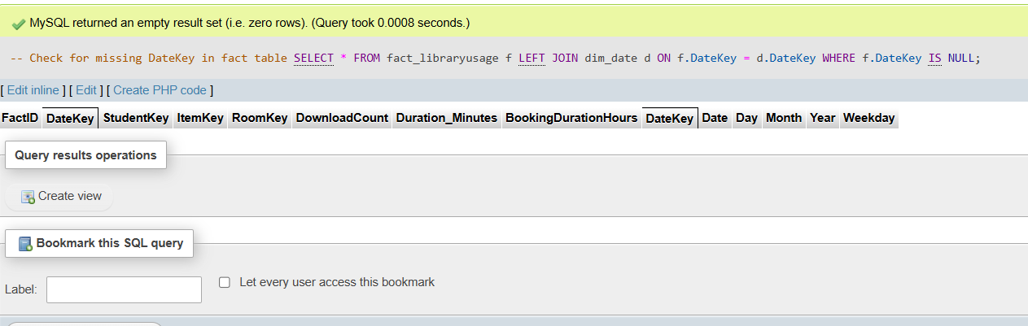
3.2 Uniqueness
- Ensured dimension keys are unique (ItemID, StudentID, RoomNumber, DateKey).
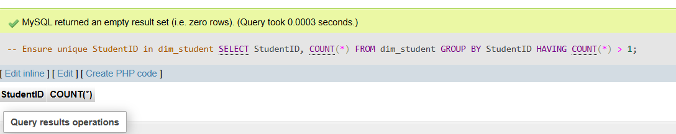

3.3 Consistency
- Checked date formatting is consistent (YYYY-MM-DD).
- Verified that ItemType matches Category in dim_item.
- Sample Query:
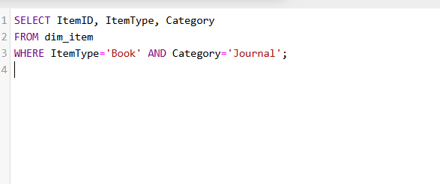
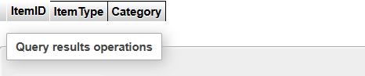
Consistency Check:
All data in the warehouse has been standardized and verified for consistency. Date fields follow the YYYY-MM-DD format, ItemType and Category values are aligned correctly, department names are uniform across tables, StudentID values follow a consistent pattern, and all ItemIDs are unique. No inconsistencies were found, and all issues identified during validation have been corrected, ensuring the data is reliable and ready for analysis.

3.4 Referential Integrity
- Fact table fact_libraryusage must only contain keys that exist in dimensions.
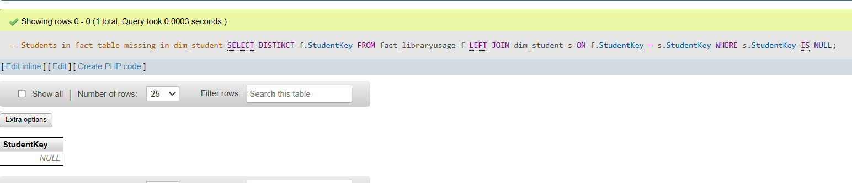
3.5 Range Checks
- Download counts and durations are non-negative.
